# Verification of codes with permeation simulations

Material: Tungsten

Atomic density:  **Wm-3**

Tetrahedral interstitial site (TIS) density: $N_{TIS}=6ρ_{W}$

Diffusion **m2s-1**

Solubility $S_{H}\left(T\right)=2.9×{10}^{-5}\exp\left(-\frac{1.00 eV}{k_{B}T}\right)$**H/W Pa-1/2**

Trap parameters:

There are 3 trap types in the simulations:

Trap 1 and trap 2 are intrinsic traps: $∀ x∈\left[0,L\right], n_{i}\left(x\right)=n_{t,i}$

Trap 3 is close to the surface: $n_{i}\left(x\right)=\frac{n_{t,i}}{1+\exp\left(\frac{x-x_{0}}{δx}\right)}$ with $x_{0}=10$ nm and $δx=2$ nm.

For each trap, the trapping energy is the diffusion energy $E_{t}=0.2$ eV.

For each trap, the pre-exponential frequency for trapping ( $t$ indices) and detrapping ( $dt$ indices)are  **s-1**

The detrapping energy $E_{dt,i}$ and trap concentration $n_{t,i}$ are obtained through a parametric optimization. Thus, there are 6 parameters to determine.

Boundary conditions:

At both sides of the material, a Dirichlet Boundary recombination $c_{m}\left(0,L\right)=0$ is used. It represents the case where the recombination is not limiting the desorption of D.

Sample and exposure conditions:

We want to simulate the experimental results described in [Ogorodnikova, Roth and Mayer, Deuterium retention in tungsten in dependence of the surface conditions, J. Nucl. Mater. 313-316 (2003) 469-477]. The TDS spectra to be simulated is given in figure 5 of this reference (fluence 1023 D/m2).

Thickness: $L=500$ **µm**

Exposure condition and TDS:

1. 200 eV/D implantation, D/m2/s at 300 K for 4000 seconds: if the reflection coefficient of the ions is considered to be around 0.5 for normal incidence, the incident fluence is 1023 D/m2.
2. A storage phase at 300 K (no flux, atoms or molecules)
3. A TDS steps with a ramp of 8 K/s: from 300 K to 1100 K in 100 secondsack side)

Results:

The optimization on the 6 parameters leads to the set of following parameters for a relative error of 2.91%:

|  |  |  |  |
| --- | --- | --- | --- |
|  | Trap 1 | Trap 2 | Trap 3 |
| $E_{dt,i}$ (eV) | 0.834 | 0.959 | 1.496 |
| $n_{i}$ (at.fr.) | 1.364×10-3 | 3.629×10-4 | 9.743 ×10-2 |

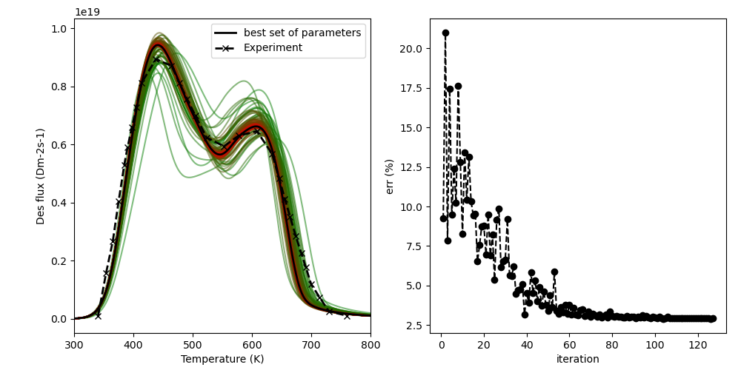

Figure 1. left) comparison between the simulation and the experiments during the optimization process. Right) evolution of the error ($\frac{∑|a_{e}\left(t_{i}\right)-a_{sim}\left(t_{i}\right)|}{∑a_{e}(t_{i})}$) during the optimization.

This results are not far from the calculated value I obtained in the first MHIMS paper [Hodille et al., J. Nucl. Mater. 467 (2015) 424-431] (I was then using the experimental results of the lower fluence shown in the paper by Ogordnikova, Roth and Mayer). In my PhD thesis, I also simulated this data and come up with similar trapping parameters (0.85 eV/1.3×10-3 at.fr., 1.00 eV/4×10-4 at.fr. and 1.5 eV for the surface trap) that I used as initial guesses for the optimization. At that time, I was not doing the optimization automatically so my results could have been not optimized.